1. Transfer function of the system

H(Z) = (0.1 – 0.12 × Z^-1 + 0.1 × Z^-2)/(1 – 1.7 × Z^-1 + 0.8 × Z^-2)

2.

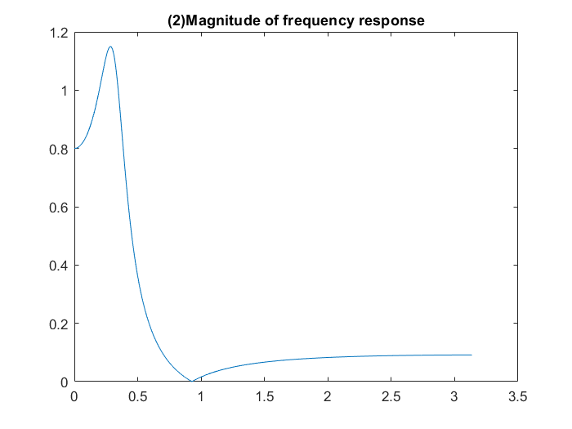

3. Observations

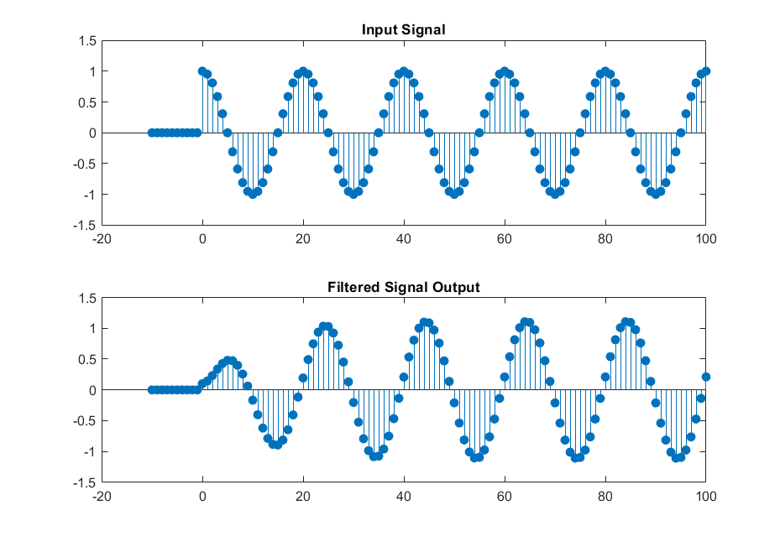

(a) Amplitude of input and output signal is approximately the same.

(b) Output signal is phase shifted.

4. H f (ω) at ω = 0.1π

h1 = 0.2109 + 1.0954i

5.

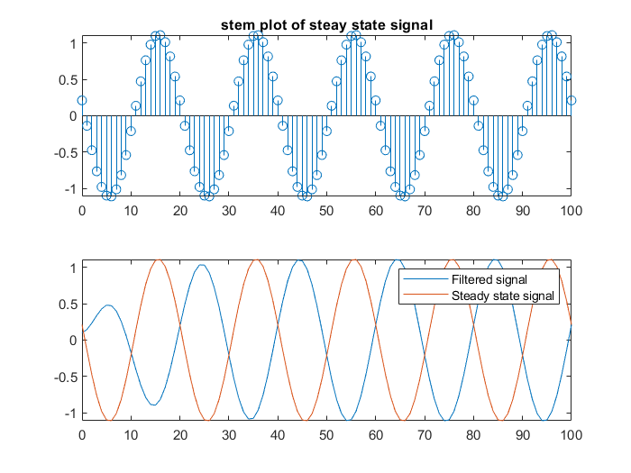

6.

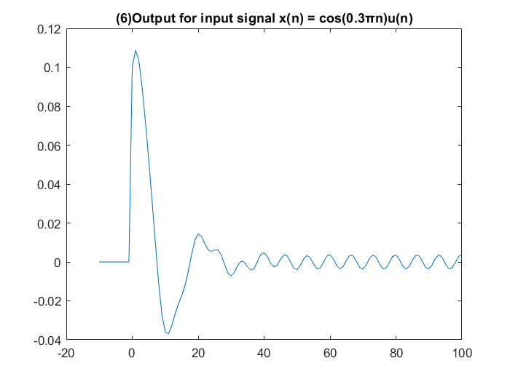

From frequency response magnitude of system input signal frequency (0.3 π) is very close to the frequency where output becomes 0, therefore output is magnitude is very low. Even though initial transient signal is big, eventually it diminishes leaving signal with maximum amplitude of 0.003 approximately.

7.

. 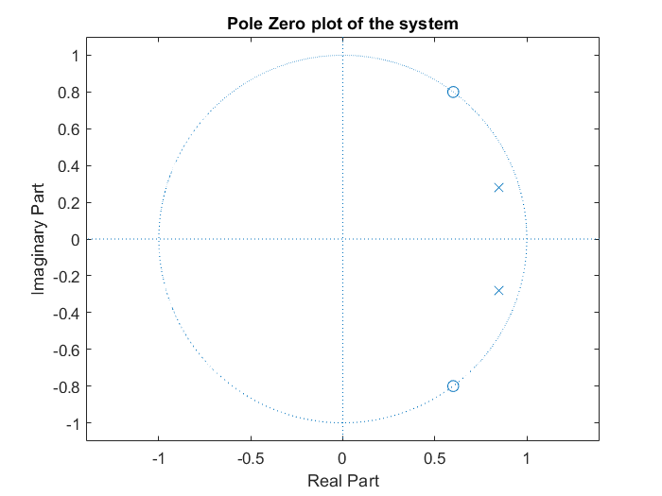s